Year 4 Planning – History
My learners:
Strengths:

Interests:

Needs:

Inquiry Focus: What was life like for Aboriginal and/or Torres Strait Islander Peoples before the arrival of the Europeans?

General Capabilities Focus:
Literacy
Numeracy
ICT capability
Critical and Creative Thinking
Personal and Social Capability
Ethical behaviour
Intercultural Understanding

Cross Curriculum Priorities:
Aboriginal and Torres Strait Histories and Culture
Asia and Australia’s Engagement with Asia
Sustainability

Year 4 Level Description
First Contacts
The Year 4 curriculum introduces world history and the movement of peoples. Beginning with the history of Aboriginal and Torres Strait Islander peoples, students examine European exploration and colonisation in Australia and throughout the world up to the early 1800s. Students examine the impact of exploration on other societies, how these societies interacted with newcomers, and how these experiences contributed to their cultural diversity.
The content provides opportunities to develop historical understanding through key concepts including sources, continuity and change, cause and effect, perspectives, empathy and significance. These concepts may be investigated within a particular historical context to facilitate an understanding of the past and to provide a focus for historical inquiries.
The history content at this year level involves two strands: Historical Knowledge and Understanding and Historical Skills. These strands are interrelated and should be taught in an integrated way; they may be integrated across learning areas and in ways that are appropriate to specific local contexts. The order and detail in which they are taught are programming decisions.
A framework for developing students’ historical knowledge, understanding and skills is provided by inquiry questions through the use and interpretation of sources.
The key inquiry questions at this year level are:
- Why did the great journeys of exploration occur?
- What was life like for Aboriginal and/or Torres Strait Islander Peoples before the arrival of the Europeans?
- Why did the Europeans settle in Australia?
- What was the nature and consequence of contact between Aboriginal and/or Torres Strait Islander Peoples and early traders, explorers and settlers?

Content Desciptors
Historical Knowledge and Understanding  First Contacts  The diversity and longevity of Australia’s first peoples and the ways Aboriginal and/or Torres Strait Islander peoples are connected to Country and Place (land, sea, waterways and skies) and the implications for their daily lives. (ACHHK077)  The journey(s) of AT LEAST ONE world navigator, explorer or trader up to the late eighteenth century, including their contacts with other societies and any impacts. (ACHHK078)  Stories of the First Fleet, including reasons for the journey, who travelled to Australia, and their experiences following arrival. (ACHHK079)  The nature of contact between Aboriginal people and/or Torres Strait Islanders and others, for example, the Macassans and the Europeans, and the effects of these interactions on, for example families and the environment (ACHHK080) | Historical Skills  Chronology, terms and concepts  Sequence historical people and events (ACHHS081)  Use historical terms (ACHHS082)  Historical questions and research  Pose a range of questions about the past (ACHHS083)  Identify sources (ACHHS216)  Analysis and use of sources  Locate relevant information from sources provided (ACHHS084)  Perspectives and interpretations  Identify different points of view (ACHHS085)  Explanation and communication  Develop texts, particularly narratives (ACHHS086)  Use a range of communication forms (oral, graphic, written) and digital technologies (ACHHS087)

Year 4 Achievement Standard
By the end of Year 4, students explain how and why life changed in the past, and identify aspects of the past that remained the same. They describe the experiences of an individual or group over time. They recognise the significance of events in bringing about change.
Students sequence events and people (their lifetime) in chronological order to identify key dates. They pose a range of questions about the past. They identify sources (written, physical, visual, oral), and locate information to answer these questions. They recognise different points of view. Students develop and present texts, including narratives, using historical terms.

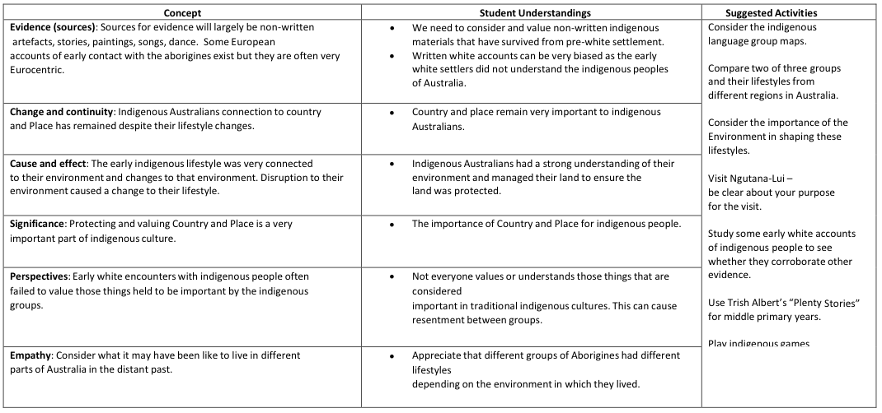

Learning and Teaching Cycle |  | Assessment Opportunities | Resources
Engage | Explore various resources about A & TSI culture and ways of life – see links in resources. Discuss stories, paintings, song, dance and totems  Explore maps to locate TSI and also language groups (see map link in resources) | Pearson New Resource – choose four words and find out which Aboriginal language that the words originally came from. | Youtube clip  https://www.youtube.com/watch?v=OEVifIIQ9fI  Dust Echoes - videos of indigenous stories  Scootle - TSI (Totem and TS headdress)  Scootle - TSI 2 (Islands in the TS)  Indigenous language map  Texts from library
Explore | Discuss key question + KWL  Explore artefacts from Qld Museum – (Hiborrow from Museum), (and personal artefacts from students’ – boomerang/art)  Pose question about artefacts relating to what life was like – 5W1H | Use LIFE for students to pose and answer questions on a forum. | Youtube clip - first australians (before the dreaming)  Question wall  qld museum kits - link  My place link (comparison of Aboriginal and recently new settler children on timeline).
Explain | Students to find sources and locate information about culture and ways of life  Visit oval to show physical idea of timeline – distance between 60000/40000/20000 years ago and last 2000 or so years with rope  Students create a digital timeline | Bubbl.us to create concept map  Timeline | Websites and texts  good history timeline  Timeline of aboriginal history  http://www.humanrights.gov.au/timeline-history-separation-aboriginal-and-torres-strait-islander-children-their-families-text
Elaborate | Compare two groups (coastal and central) and their lifestyles from different regions in Australia  Consider the importance of the Environment in shaping these lifestyles  Ngutana-lui visit | Venn diagram showing similarities and differences | Pictures of weapons, clothing, housing, food to compare and contrast  Newspaper article about use of fire to manage environment  ngutana-lui  Use Trish Albert’s “Plenty Stories” for middle primary years (suggestion from Kweb)
Evaluate | Y Chart | Y Chart what did life look like, sound like, feel like for indigenous Australian before settlement

